Software Design Description (SDD)
The SDD currently represents the system as a single Spring Boot application consisting of the following internal modules/services:
- Authentication Module
- User Management Module
- Vehicle Module
- Service Request Module
- Parts Inventory Module
- Billing Module
- Reporting Module
- Notification Module
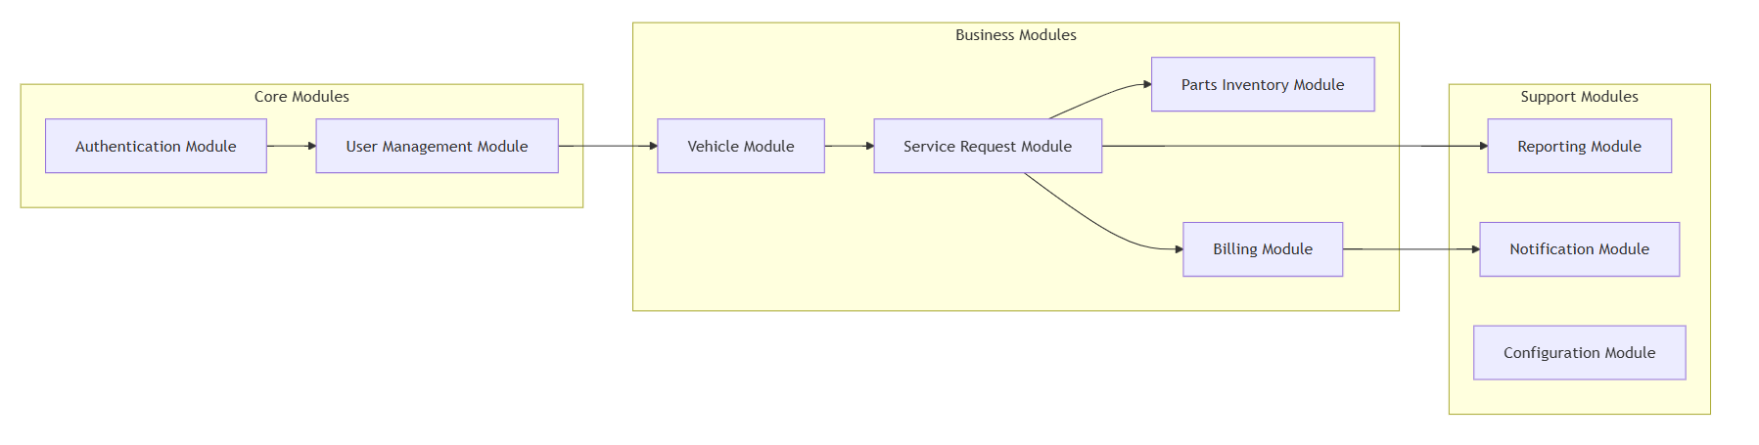

Microservices Breakdown
- Auth Service
Handles authentication-related functionality such as user registration, login, JWT token generation, and token refresh.
Base endpoint: /api/auth/**
- User Service
Manages user accounts, user profiles, and technician listings.
Base endpoint: /api/users/**
- Vehicle Service
Responsible for vehicle management including CRUD operations and vehicle service history.
Base endpoint: /api/vehicles/**
- Service Request Service
Handles core service operations such as service booking, technician assignment, status updates, category management, and bay management.
Base endpoints:
/api/service-requests/**
/api/categories/**
/api/bays/**
- Inventory Service
Manages spare parts inventory, stock levels, and low-stock alerts.
Base endpoint: /api/parts/**
- Billing Service
Responsible for invoice generation and payment tracking.
Base endpoint: /api/invoices/**
- Reporting Service
Provides dashboards, analytics, and various system reports.
Base endpoint: /api/reports/**
- Notification Service
Handles email and SMS notifications. This service is internal and does not expose public APIs.
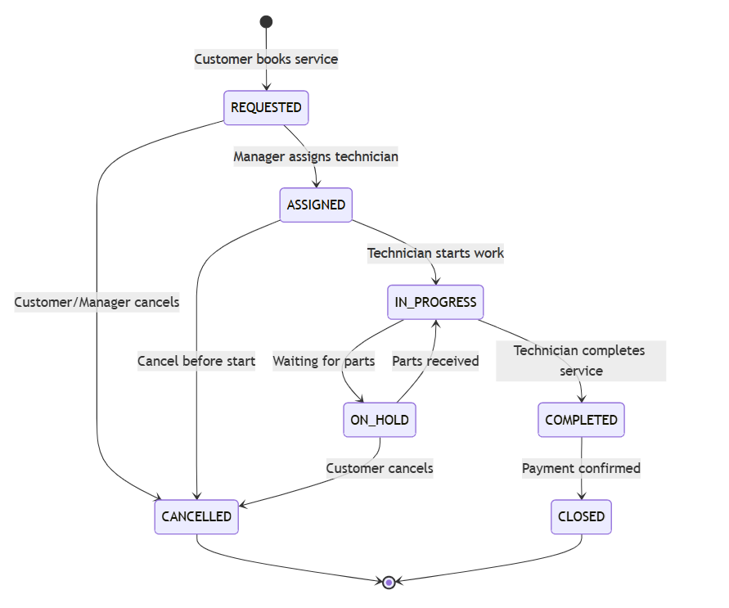

6.1 Auth Service
Responsibilities
- User registration and login
- Password encryption and validation
- JWT access and refresh token management
- Role-based access control enforcement
APIs
- POST /api/auth/register
- POST /api/auth/login
- POST /api/auth/refresh
- GET /api/auth/me
Database
- auth_db
  - users_auth
  - roles
  - refresh_tokens

6.2 User Service
Responsibilities
- User profile management
- Role assignment and user status management
- Technician listing and availability management
APIs
- GET /api/users
- GET /api/users/{id}
- PUT /api/users/{id}
- DELETE /api/users/{id}
- GET /api/users/technicians
Database
- user_db
  - users
  - user_profiles
  - technicians

6.3 Vehicle Service
Responsibilities
- Vehicle registration and ownership management
- Vehicle CRUD operations
- Tracking vehicle service history
APIs
- GET /api/vehicles
- GET /api/vehicles/{id}
- POST /api/vehicles
- PUT /api/vehicles/{id}
- DELETE /api/vehicles/{id}
- GET /api/vehicles/{id}/history
Database
- vehicle_db
  - vehicles
  - vehicle_owners
  - service_history

6.4 Service Request Service
Responsibilities
- Service request creation and management
- Technician assignment and status tracking
- Service category management
- Service bay allocation and availability tracking
APIs
- GET /api/service-requests
- GET /api/service-requests/{id}
- POST /api/service-requests
- PUT /api/service-requests/{id}
- PATCH /api/service-requests/{id}/assign
- PATCH /api/service-requests/{id}/status
- POST /api/service-requests/{id}/cancel
Category APIs:
- GET /api/categories
- POST /api/categories
- PUT /api/categories/{id}
- DELETE /api/categories/{id}
Bay APIs:
- GET /api/bays
- GET /api/bays/available
- PATCH /api/bays/{id}/assign
- PATCH /api/bays/{id}/release
Database
- service_request_db
  - service_requests
  - service_categories
  - service_bays
  - assignments

6.5 Inventory Service
Responsibilities
- Spare parts catalog management
- Stock level monitoring
- Low-stock alert tracking
APIs
- GET /api/parts
- GET /api/parts/{id}
- POST /api/parts
- PUT /api/parts/{id}
- DELETE /api/parts/{id}
- GET /api/parts/low-stock
Database
- inventory_db
  - parts
  - stock_levels
  - stock_movements

6.6 Billing Service
Responsibilities
- Invoice generation for completed services
- Payment tracking and status updates
- Customer billing history management
APIs
- GET /api/invoices
- GET /api/invoices/{id}
- POST /api/invoices/generate/{serviceRequestId}
- PATCH /api/invoices/{id}/payment
- GET /api/invoices/customer/{customerId}
Database
- billing_db
  - invoices
  - invoice_items
  - payments

6.7 Reporting Service
Responsibilities
- Dashboard statistics generation
- Revenue analysis and reporting
- Technician workload and performance analysis
- Inventory and service analytics
APIs
- GET /api/reports/dashboard
- GET /api/reports/services/summary
- GET /api/reports/technician/workload
- GET /api/reports/revenue/monthly
- GET /api/reports/parts/usage
Database
- reporting_db
  - aggregated_metrics
  - revenue_reports
  - workload_reports
(Read-only access to other service databases for analytics)

6.8 Notification Service
Responsibilities
- Sending email notifications
- Sending SMS alerts
- Event-based notification handling
APIs
- Internal service only (no public endpoints)
Database
- notification_db
  - notification_logs
  - Templates
OPENFEIGN:
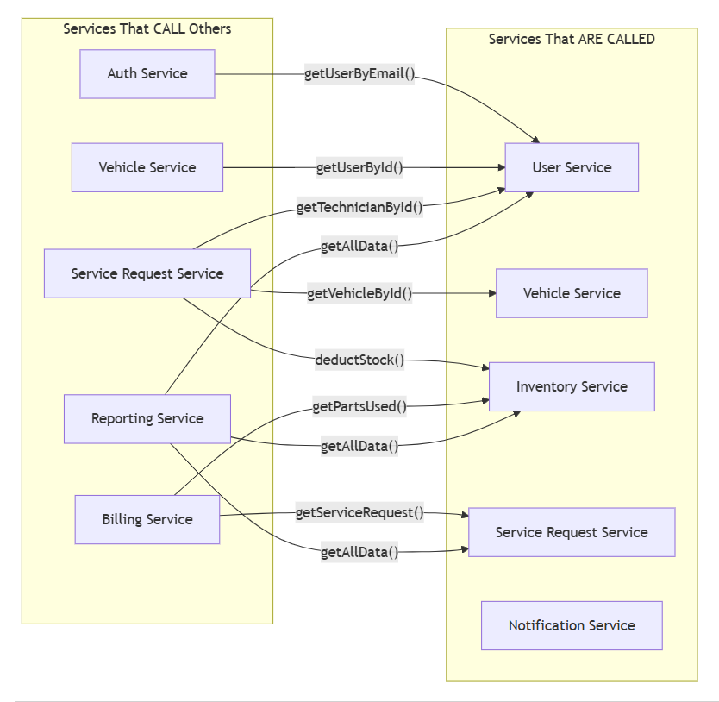

DATA DESIGN (LLD)

1.User Document

{
"id": 101,
"email": "user@test.com",
"password": "encrypted_password",
"UserName": "Sharanya",
"phone": "9876543210",
"role": "CUSTOMER",
"active": true
}

2.Vehicle Document
{
"id": "v201",
"ownerId": "u101",
"registrationNumber": "KA01AB1234",
"make": "Honda",
"model": "City",
"year": 2022,
"vehicleType": "CAR",
"color": "White"
}

3.Service Category Document
{
"id": 301,
"name": "Engine Repair",
"description": "Complete engine diagnostics and repair",
"basePrice": 2500,
"estimatedHours": 4,
"active": true
}

4.Service Request Document
{
"requestId": "sr301",
"vehicleId": "v201",
"customerId": "u101",
"technicianId": "u301",
"issueDescription": "Engine noise during acceleration",
"priority": "NORMAL",
"status": "REQUESTED",
"requestedDate": "2024-12-28T09:00:00"
}

5.Service Request Parts Document
{
"id": 601,
"serviceRequestId": 401,
"partId": 501,
"quantity": 1,
"unitPrice": 2500,
"totalPrice": 2500
}

6.Parts Inventory Document
{
"id": 501,
"partNumber": "OIL-5W30-4L",
"name": "Engine Oil 5W30",
"description": "High performance engine oil",
"unitPrice": 2500,
"stockQuantity": 40,
"reorderLevel": 10,
"active": true
}

7.Invoice Document
{
"id": 701,
"invoiceNumber": "INV-20241227-001",
"serviceRequestId": 401,
"laborCost": 2500,
"partsCost": 2500,
"taxAmount": 900,
"totalAmount": 5900,
"paymentStatus": "PENDING",
"invoiceDate": "2024-12-27T12:00:00",
"paidDate": null
}

8.Service Bay Document
{
"id": 801,
"bayNumber": "BAY-03",
"status": "AVAILABLE",
"currentServiceId": null
}

